**Fiscal Year variant, Posting Period variant and Open/close Period for Material**

**Variant Principle**

* 3-Step Method used in SAP to assign Particular Properties to one or more Object

1. Step: Define the variant
2. Step: Determine Values for the Variant
3. Step: Assign the variant to the objects

* **Type of Variants:**
* Fiscal Year Variant, Posting Period Variant, Chart of accounts, Field Status Variants, Screen Variants are Created by Followings the 3-step method of Variant Principle.
* **Advantage For Using Variants:**
* It is easier to maintain Properties Which are common Among Several Business Objects.

**Fiscal Year**

Fiscal Year is nothing but the**accounting period which normally spreads over 12 months**. The financial statements are drawn for a fiscal year in SAP. In SAP Fiscal year is defined as **Fiscal Year Variant**.

**Fiscal Year variants**

Fiscal year variant contains the number of posting periods in a fiscal year and the number of special periods. You can define up to 16 posting periods in a fiscal year in the controlling component CO. This Fiscal Year Variant holds the total 16 numbers of posting periods in which 12 normal posting periods and 4 special periods. Special Periods Are Used for Postings for Year-end Closing. A Special Period is a Posting Period Which is used to divide the last Regular Posting Period for Closing Operations.

**In SAP Fiscal Year Can Be defined as year Independent and Year Dependent.**

1. **Year – Independent:**

* The Number and Start and End Dates For the periods Are the same For Every year.
* Year-Independent Can Be Define as Calendar year (Templates: K0, K1, K2, K3, K4) And Non-calendar Year. (non-calendar used +1 or -1 indicator to represent the period of year).

1. **Year – Dependent:**

* Periods Can Vary from Year to Year:

1. For Example: If the Start and End Date of the Posting Periods Differ from Year to Year.
2. A Shortened Fiscal Year
3. Template: AA, AM, RI, UL, WK

* Table: T009 can be view through T-Code: SE16N to Display the list of Information.

**Transaction Code:** OB29

**Menu Path: SPRO 🡪 IMG 🡪** Financial Accounting 🡪 Financial Accounting Global Settings 🡪 Fiscal Year and Posting Periods.

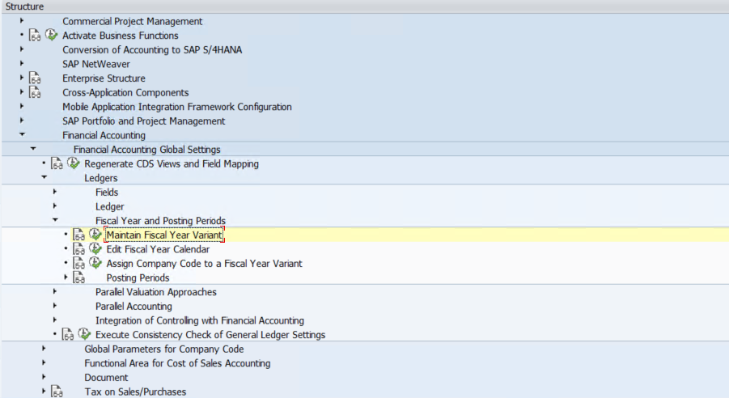

**Posting Period Variant**

It is useful In opening/closing posting periods for more than one company code at one time. You Define one posting Period Variant and Can Assign it to various company codes.

In Order to prevent postings into the wrong period, we can close all the period except the current one. During month-end closing, you Can close the current period and open the next one. During year-end closing, you open the special periods and also make sure that two period intervals must be open at the same time.

Eg. In the period 12, open the special periods as internal 1 and open first two period for the new Fiscal year as interval 2.

**Posting periods can be handled differently for different account Types:**

1. **The Account type: “+”** must be open for all the period that are supposed to be open for all other account types.
2. **The First Interval:** In the posting period specifies the 12 normal period.
3. **The Second Interval:** In the posting Period Specifies the 4 Special Periods.
4. **The Authorization Group:** It is used to allow Specific Users to Post in a Period/Periods. In Other Words, it is used to open a period for Specific User.

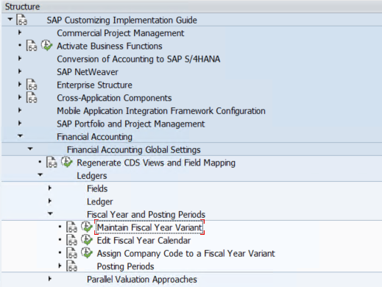

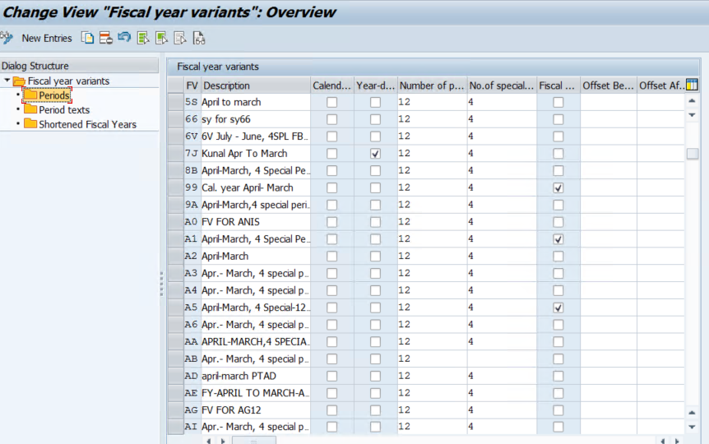

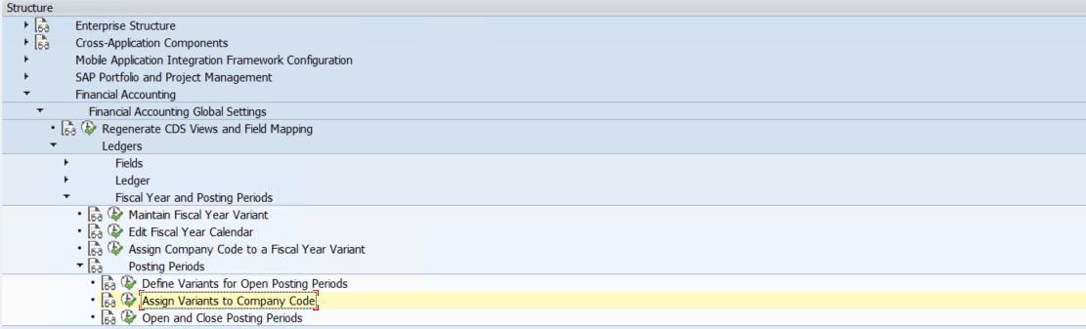

**Field Status Variant**

Field Status Variant Control the fields of a Transaction at a line-item Level.

For Example, if you want to make a field to supposed(hide), Required Entry, and optional entry, then you can user it through field status variants / Group Assigned in Company Code Segment of a G/L Master. Field Status Variants can be created by following the 3-step method of Variants Principle. It is 4-digits Alphanumerical key. SAP Provides Pre-define Filed Status Group which can be copies to create your own.

Define Field status Variants: **T-Code: OBC4**.

**Menu Path:** Display IMG 🡪 Financial Accounting 🡪 Financial Accounting Global Settings 🡪 Ledgers 🡪 Fields 🡪 Define Fields 🡪 Define Filed Status Variants.

If You Don’t Maintain the field status, all Fields Will be Hidden.

* Assign Company Code to the field status Variants: **T-Codes: OBC5**

**Menu Path:** Display IMG 🡪 Financial Accounting 🡪 Financial Accounting Global Settings 🡪 Ledgers 🡪 Fields 🡪 Assign Company Code to Field Status Variants.

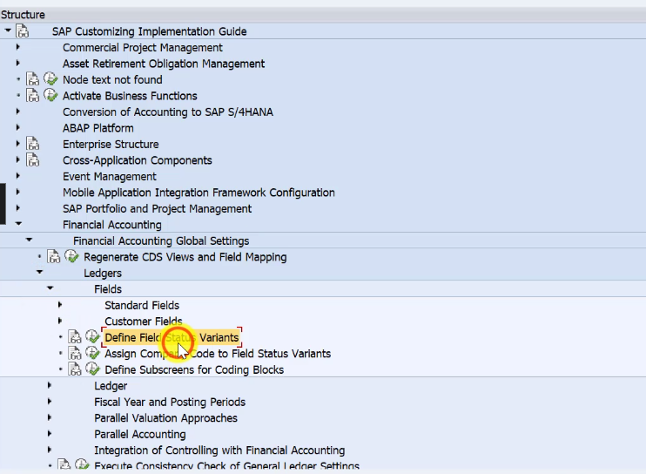

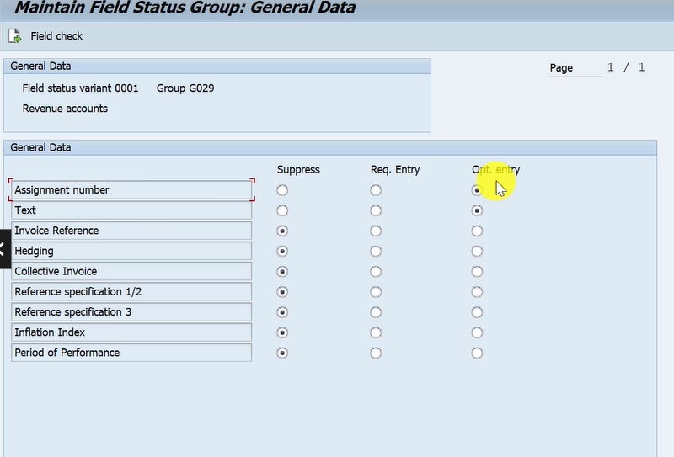

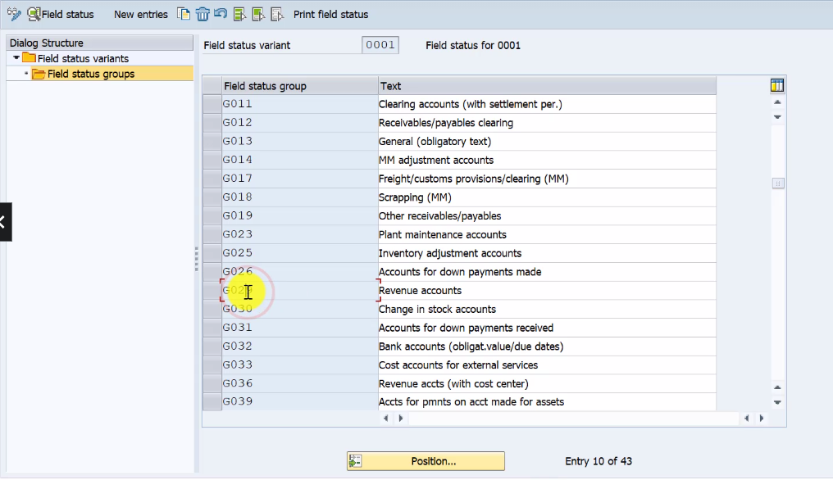

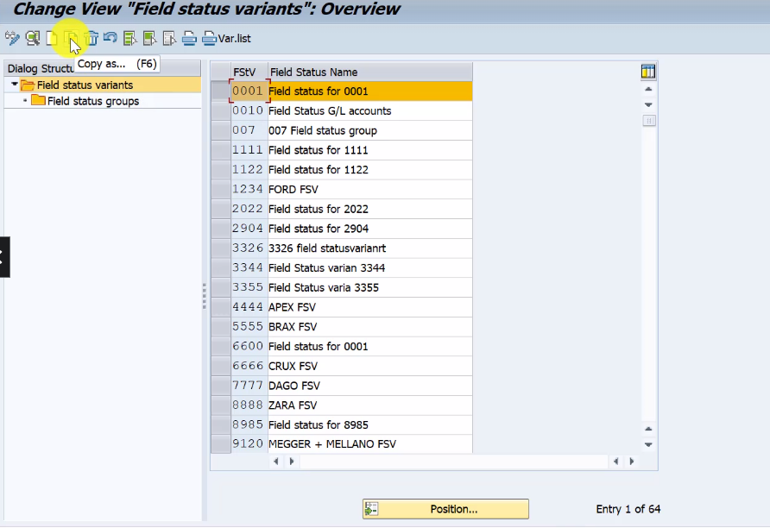

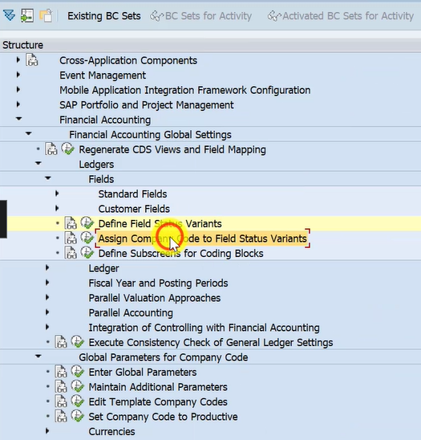

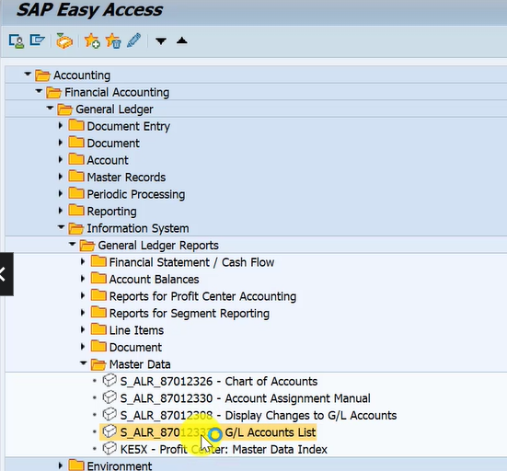

* Table Name For G/L Account Master **(Chart of Accounts)** ---- SKA1 (INT)
* Table Name For G/L Account Master **(Chart of Account: Key Word List)** ---- SKAS
* Table Name For G/L Account Master **(Company Code)** ---- SKB1

**T-code 🡪 OBC4**

**T-code 🡪 OBR1** for change G/L Account for C-code.

**T-code 🡪 OBR2** for change G/L Account for C-code

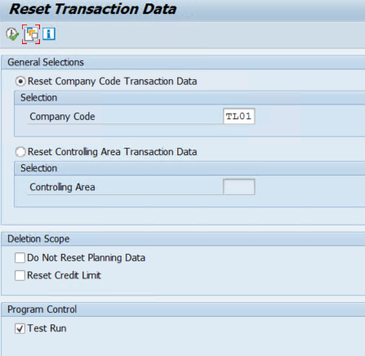

**SAP S/4 HANA Souring a Procurement / Material Management (MM)**

* Open/Close Period for Material Master Records

1. To Set the Current Period for MM

* **T-Code: OMSY –** Material Management View on Company Code
* **Menu Path:** Display IMG 🡪 Logistics – General 🡪 Material Master 🡪 Basic Settings 🡪 Maintain Company Codes for Material Management

1. To Open the Previous Period in MM

* **T-Code: MMRV –** Allow Posting to Previous Period
* **Menu Path:** Sap Easy Access 🡪 Logistics 🡪 Material Management 🡪 Material Master 🡪 Other 🡪 Allow Posting to Previous Period

1. Close Period for Material Master Records

* **T-Code: MMPV –** Close Period for Material Master Records
* **Menu Path:** Sap Easy Access 🡪 Logistics 🡪 Material Management 🡪 Material Master 🡪 Other 🡪 Close Period.

